ACCESS REQUEST PROFORMA V.2.4

YOU MUST COMPLETE THIS REQUEST PROFORMA & SUBMIT THIS ALONG WITH YOUR RAMS: Complete & Include this proforma when you submit your RAMS for review; this will then be included in your RAMS bundle when submitting an access request.
IMPORTANT! FAILURE TO PROVIDE THIS INFORMATION WILL RESULT IN YOUR ACCESS REQUEST BEING REJECTED.
(Your work sponsor should provide you with the information you need to complete this form).

Company Name: | Your work Sponsor:
Proposed date of works: | Job Reference/CAF-CC Number:
UBS Line Manager: | Cost Centre

Do you require a Security Escort? (if not leave blank)
Date | Day | No of Escorts | Time (from) | Time (to) | Location/s | Activity
 | Saturday
 | Sunday
 | Monday
 | Tuesday
 | Wednesday
 | Thursday
 | Friday

Do you require an Engineering Escort? (if not leave Blank)
Date | Day | No of Escorts | Time (from) | Time (to) | Location/s | Activity

Details of those listed on your access request (Mandatory – You MUST complete this section)
(Provide as much information as possible – names listed without any information cannot be processed)
First name | Surname | *Type of Pass held | Requested Security Induction date | SNOW/ RITM number | Change number | GPIN number
*Pass types: Paper Pass / Grey Photo Card / Building Access Only Card / Secure Pass NB: additional sheet overleaf

SEE OVERLEAF FOR H&S AND SECURITY INDUCTION INFORMATION

H&S INDUCTION – IMPORTANT! All operatives listed on an access permit are required to complete our H&S Induction before attending site for their Security Induction. The H&S Induction can be found on the e-Permits log in page; watch the video, answer the 8 questions. Upon successful completion the following will appear (in your personal profile):

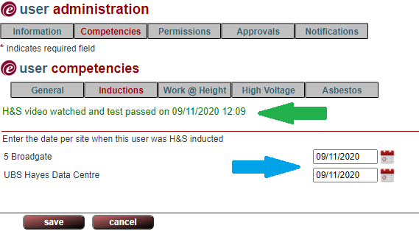 |  | When the Induction has been completed the text (see green arrow) will appear in the tabs indicated in your personal profile. You will then be required to populate this information in the boxes indicated by the blue arrow.  Failure to undertake the H&S and to update you/your operatives’ profiles will result in access being denied.

SECURITY INDUCTION INFORMATION:
All inductions are held weekly on a Thursday at 5 Broadgate at 09.00, attendees to arrive by 08.45 at the Contractor Entrance – late arrivals may not be permitted.
Failure to present the appropriate ID will result in refusal of attendance – see correct ID below.
Persons requiring a blue or yellow pass must be issued with a GPN prior to attending the induction.
UK CITIZENS APPROPRIATE ID:  - UK Passport  or  - Birth certificate together with an official document giving the name and NI number (e.g. issued by HMRC/previous employer e.g. P45, P60)  or  - Certificate of naturalisation together with an official document giving the name and NI number (e.g. issued by HMRC/previous employer e.g. P45, P60) | EU/EEA CITIZENS APPROPRIATE ID:  EU or Swiss passport or ID card | NON-EU CITIZENS APPROPRIATE ID:  - Passport and indefinite leave to remain  or  - Passport and Tier 1 general  or  - Passport and work permit issued for EEA/Switzerland family members  or  - Passport and right to abode  or  - Passport and work permit issued for UK citizen dependant

Additional Information Box (use this space to let us know anything you think we need to know in regards your access request)

The isolation maps are attached to the RAMS for smoke & sprinkler isolations .

Guidance Notes:

- Escort requirements – Please state if your work is Planned Preventative Maintenance (PPM). In the ‘Activity’ box
(if applicable).

